**C/C composites developed from phthalonitrile based composites**

Vladislav V Aleshkevich 1,2,3, Alexander V Babkin 1,2, Victor V Avdeev1,2

1Faculty of Chemistry, Lomonosov Moscow State University, Leninskie gory, 1-3, 119991 Moscow, Russia;

2Institute of New Carbon Materials and Technologies, Leninskie gory, 1-11, 119991 Moscow, Russia;

3Corresponding author, e-mail: vladislav.aleshkevich@gmail.com

**Abstract**

Carbonization of carbon fabric reinforced plastics (CFRPs) with phthalonitrile matrices at 1000°C was investigated. Four different carbonization modes were tested. It was explored, that a mode with step heat rate is most beneficial. Two different phthalonitrile resins were investigated. Elemental analysis of final carbon-carbon composite (C/C) matrix was carried out and the results showed up to 88.5 mass% carbon presence. Final C/C density reached 1.5991 after only one cycle of impregnation-carbonization. Final porosity of samples reached 9.2%. These results allow to consider phthalonitriles as a prospective carbon precursor for C/Cs manufacturing. Mechanical testing of the C/C samples was performed (Compressive strength P = 72.2MPa, E = 11.8 GPa). Tribological data was received (coefficient of friction = 0.31, wear rate = 30 µ/min). Thermal analysis was carried out (χ = 72.94 W/m*K, α = 85.8 cm2/s).

**Keywords:** Carbon-carbon composites, phthalonitriles, carbonization

1. **Introduction**

Carbon-carbon composites (C/Cs) are the class of composite materials where both matrix and reinforcement are different forms of carbon. C/Cs not only retain mechanical strength at high temperatures, but even increase it[1]. One of the key features of C/C composites providing the most widespread application of these materials is the best tribological characteristics at high temperatures. The use of the brake discs made of C/C composites in heavy vehicles and aircrafts allows to significantly reduce a braking distance[2].

One of the most effective ways to obtain C/Cs is a carbonization of carbon-fiber reinforced plastics. Phenolic resins became common polymer precursors to form carbon matrix for C/C composites due to its low price. Despite high carbon content phenolic resins characterized by moderate char yield, namely 55-67%[3]. High porosity and low mechanical properties after carbonization require several cycles of impregnation and carbonization to obtain material with suitable characteristics. Thus, a process of brake disc manufacturing takes about 6-8 month from CFRP to C/C composite with target characteristics.

Phthalonitrile matrices demonstrate high char yields (70-80%)[4,5]. The development of low-melting resin formulations [6] allows to use cost-effective CFRP processing by vacuum infusion [7,8] or RTM [9]. Accordingly, phthalonitrile resins are prospective precursors for carbon matrices in C/C composites.

1. **Materials and Methods**

All the manipulations with oxidation and moisture sensitive compounds were carried out under inert atmosphere using the standard Schlenk technique. All the solvents were purchased from Alfa Aesar and purified according to the standard procedures [10] and stored under Ar. Dimethylacetamide (DMAc) was distilled over CaH2. Pyridine was distilled over CaH2 and stored under Ar. Resorcinol, 4-nitrophtalonitrile, 1,3-bis(4-aminophenoxy)benzene (APB) (Figure 1, **1**), propargyl chloride, potassium bromide and potassium carbonate were obtained from Aldrich and used as received. 4-(3-(prop-2-ynyloxy)phenoxy)phthalonitrile (Figure 1, **2**) was synthesized in accordance with the published procedures [11].



Figure 1 Structures of 1,3-bis(4-aminophenoxy)benzene (APB) and 4-(3-(prop-2-ynyloxy)phenoxy)phthalonitrile

Carbon fabric 22502 from JSC INCMaT 2 × 2 twill wave from 3k HTA40 TohoTenax from Teijin fiber was used for CFRP preparation. For the matrix materials, phthalonitrile based resins obtained from ITECMA were used. Auxiliary materials for vacuum infusion were purchased from Airtech.

All NMR spectra were measured at 600 MHz (1H) and 151 MHz (13C) on a Bruker Avance III Ultrashield spectrometer. All NMR spectra were recorded in deuterated dimethylsulfoxide with reference to tetramethylsilane. Melt viscosity was measured with MCR 302 Rheometer with cone 10 at 200 r/min. Composite density was measured with a Vibra ht-220-CE according to hydrostatic weighing method in pure octane. STA data for samples mass loss was measured with a Netzsch STA 449 at heating rate of 10°C/min in a range of 40–980°C with Ar or air as s purge gases. Porosity analyses were performed on a Microactive Autopore v9600 (capillary nitrogen adsorption) and an an ASAP 2020 Plus (mercury porosimetry). SEM microphotographs were obtained using a Vega 3 (Tescan) microscope with secondary electron detector at operating voltage of 20kV. Interlaminar shear strength was measured with a Tinius Olsen 50ST according to GOST 32659-2014. Compression strength and elasticity modulus were measured with an Instron 5985 according to GOST 9550-81. Tribological characteristics were measured with a Bruker UMT-TRIBOLAB and CETR UMT2. Differential scanning calorimetry (DSC) was performed on a Netzsch DSC 449 at heating rate of 10°C/min and an Ar purge rate of 50 mL/ min. DSC was applied for determination of specific heat capacity of the resulting C/Cs according to ASTM E1269-11. Heat conductivity for resulted C/Cs was measured with a Netzsch LFA 457. Elemental analysis was measured with an automatic analyzer CE1106.

Vacuum infusion process was used to manufacture CFRP samples. Commercial phthalonitrile-based resin PN-3M (ITECMA, Russia) [12]and a formulation PPN, contained **1** and **2** in the ratio of 1:10, were used. The full process of infusion was described earlier[7]. Vacuum infusion process was performed at 150°C for PN-3M and at 120°C for PPN. Curing process was conducted at 180°C for 8h and post-curing was conducted at 375°C for both resins. Obtained composite materials as well as samples of the cured resins were carbonized. This process was carried out in a high temperature oven with different modes under nitrogen atmosphere. Nitrogen was supplied to the furnace using polyamide pipes going from cryogenic storage Dewar’s tank filled with liquid N2. The samples were put into the fine powder coke to avoid probable oxidation. Tested modes of the carbonization process are shown in Table 1.

Table 1 Carbonization modes

|  |  |  |  |  |
| --- | --- | --- | --- | --- |
| Mode | Action | Duration, min | Ending  temperature, oC | Heating  speed, °C/min |
| 1 | Heating | 100 | 1000 | 10 |
| Hold | 60 | 1000 | — |
| 2 | Heating | 1960 | 1000 | 0,51 |
| Hold | 60 | 1000 | — |
| 3 | Heating | 860 | 450 | 0,52 |
| Heating | 2880 | 800 | 0,12 |
| Heating | 400 | 1000 | 0,5 |
| Hold | 60 | 1000 | — |
| 4 | Heating | 11760 | 1000 | 0,08 |
| Hold | 60 | 1000 | — |

1. **Results and Discussion**
   1. *Carbonization modes specifying*

TGA analysis of cured resins was performed to investigate the carbonization in more details (Figure 2). The highest mass loss rate was observed at temperatures from 450 to 800°C: 16.53% for PN-3M and 17.30% for PPN. The bulk of gaseous products is expected to be removed in this interval. TGA data are shown in Table 2.

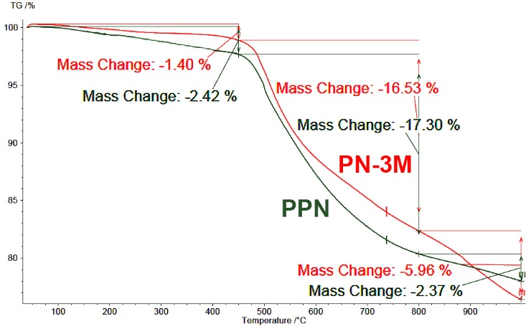

Figure 2 TGA data for PN-3M and PPN mixtures

Table 2 TGA data for used post-cured resins

|  |  |  |
| --- | --- | --- |
| Name | T5%, °C | Mass residue, % |
| PN-3M | 509 | 76,5 |
| PPN | 499 | 78,5 |

It is undesirable to use high heating speeds during carbonization, because bond cleavage, rearrangement and side products removal (e.g. H2) are taking place. It leads to shrinkage, cracking and mechanical stress gathering [13]. Low heating rates (below 10°С/min) are necessary to minimize this side processes. It was previously shown that the heating rate significantly affects the properties of the final C/Cs[14]. Cured thermoset samples of PN-3M and CFRPs with this matrix were used to investigate different carbonization modes (Figure 3). The objective of the first mode was to investigate an influence of high heating rate on carbonization of CFRPs with phthalonitrile matrices. The fourth mode was knowingly slow. The heating rate of the second mode was medium. The third mode considered the TGA data. It had a slowing step in a temperature interval from 450 to 800°C.

Figure 3 Carbonization modes

Table 3 Carbonization data for C/Cs, made from CFRPs with PN-3M matrix

|  |  |  |  |  |
| --- | --- | --- | --- | --- |
| Name | | Mass loss % | SEM pore area percentage, % | Interlaminar shear strength, MPa |
| Cured  thermoset | PN‑3M, I | 25.98 | — | — |
| PN‑3M, II | 26.61 | — | — |
| PN‑3M, III | 26.76 | — | — |
| PN‑3M, IV | 26.25 | — | — |
| CFRP | PN‑3M, I | 11.76 | 1.4 | 4.3±0.3 |
| PN‑3M, II | 14.69 | 4.3 | 5.5±0.3 |
| PN‑3M, III | 11.88 | 1.0 | 6.5±0.6 |
| PN‑3M, IV | 13.32 | 1.9 | 5.0±0.4 |

SEM analysis showed no pores or cracks in the original CFRP (Figure 4). The porous structure was obtained during the carbonization process. According to the micro-photographs pore size and pore distribution of the obtained C/Cs by different carbonization modes vary a little. To quantify the mechanical properties of the samples of composites, interlayer shifts were measured (Table 3). Obtained C/Cs by the third carbonization mode demonstrated the best results. It confirmed the importance of decreasing heat speed in the interval of the most mass loss. For further study all samples were carbonized in the third mode.

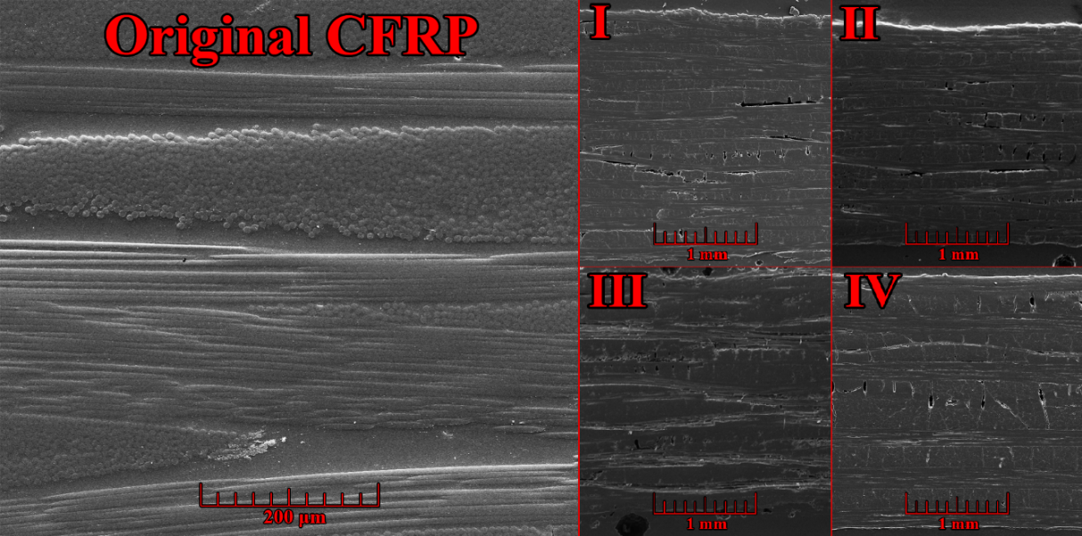

Figure 4 SEM microphotographs of original CFRP and C/C composites, made by different modes

To explore the scope of phthalonitrile resins, which could be applied as precursors for carbon matrices formation, another phthalonitrile resin composition designated as PPN was tested (PPN, C/C). The formulation consisted of 4-(3-(prop-2-yn-1-yloxy)phenoxy)phthalonitrile containing two thermosetting groups which were described previously [11] (Figure 1, **2**) and were already applied for CFRP fabrication [15], so the samples were obtained according to the reported procedure. Carbon content of PPN resin is higher than for PN-3M resin. It should allow to obtain denser samples of final CFRP. However, the porosity and mechanical properties were worse than for PN-3M, C/C (Table 4). It is also proved by comparing the density values.

Table 4 Comparing carbonization data from PN-3M, C/Cs and PPN, C/C

|  |  |  |  |
| --- | --- | --- | --- |
| Resin | Mass loss, % | ISS, MPa | Density, g/cm3 |
| PPN, C/C | 29.51 | 4.6±0.1 | 1.5392 |
| PN‑3M, C/C | 36.55 | 6.5±0.6 | 1.5991 |

To define the composition of C/Cs the elemental analysis was performed (Table 5). Despite worse mechanical properties and lower density of PN-3M- C/C, the elemental analysis data shows the higher carbon content for PPN.

Table 5 Elemental analysis data for obtained C/Cs

|  |  |  |  |
| --- | --- | --- | --- |
| Sample | w(C), % | w(H), % | w(N), % |
| PPN, C/C | 88.54 | 1.12 | 3.08 |
| PN-3M, C/C | 86.31 | 0.93 | 3.84 |

Capillary adsorption of nitrogen (micropores) and mercury porosimetry (meso- and macropores) methods were used to estimate a final porosity of C/Cs, derived earlier in this work (Table 6). Pore area (PA) for macropores is higher for PN-3M, C/C, but average pore diameter (APD) for macropores is higher for PPN, C/C. Micropores differ a little for PPN, C/C and PN-3M, C/C. General porosity is higher for PPN, C/C. Thus, pores in PN-3M, C/C are evenly distributed in volume, that can be useful for secondary impregnation-carbonization cycles.

Table 6 Porosity data for PN-3M, C/C and PPN, C/C

|  |  |  |  |  |  |
| --- | --- | --- | --- | --- | --- |
|  | N2 | | Hg | | |
| CFRP matrix | PA, m2/g | APD, nm | PA, m2/g | APD, nm | Porosity, % |
| PPN, C/C | 44.7 | 2.06 | 1.34 | 274 | 14.1 |
| PN-3M, C/C | 39.8 | 2.07 | 2.57 | 89.2 | 9.2 |

The compression tests on PN-3M, C/C were carried out (Table 7). The compressive strength (CS) and compression modulus (CM) were compared with a commercial C/Cs, derived by carbonization CFRPs with phenolic resin matrices.

Table 7 Compression data for PN-3M, C/C

|  |  |  |
| --- | --- | --- |
|  | PN-3M, C/C | Literature data |
| CS, MPa | 72,2 (noncarbonized — 403,9) | 38[16] |
| CM, GPa | 11,8 (noncarbonized — 59,21) | 11 [16] |

One of the main applications of C/Cs is manufacturing of brake disks for heavy vehicles. In that case, tribological tests on PN-3M, C/C were carried out (Table 8). Obtained data shows the competitiveness of C/Cs, obtained in this research, with C/Cs, described in literature [17].

Table 8 Tribological data for PN-3M, C/C

|  |  |  |
| --- | --- | --- |
|  | PN-3M, C/C | Literature |
| Coefficient of friction at 200 °C | 0.31 | 0.26 |
| Wear rate, µ/min | 30 | 28 |

During friction process kinetic energy transforms into heat. Thus, the ability of brakes to reject heat is very important. To estimate it, thermal tests were conducted on PN-3M, C/C: LFA method (thermal diffusivity), DSC method (specific heat capacity) and hydrostatic weighing method (density) (Table 9). The resulting values thermal conductivity were compared with phenolic-based C/Cs with PAN fiber, described in literature [16].

Table 9 Thermal characteristics of PN-3M, C/C

|  |  |
| --- | --- |
| $$χ=α*C_{p}*ρ$$ | |
| Thermal diffusivity (), cm2/s | 85.8 |
| Specific heat capacity ($C_{p}$), J/g*K | 0.514 |
| Density ), g/cm3 | 1.6540 |
| Thermal conductivity ($χ$), W/m*K | 72.94 |
| Literature data of thermal conductivity, W/m*K | 45 [16] |

1. **Conclusions**

C/C composites obtained from CFRPs with phthalonitrile matrices were investigated. The optimal carbonization conditions were selected according to interlaminar shear strength and mass loss data. The values of final porosity after one cycle are reaching 9.2%. The values of final density after one cycle is reaching 1.5991. Thus, utilization phthalonitrile resins for manufacturing C/Cs allow decreasing necessary time from 3 month to 2 weeks and manufacturing even better C/C materials.

1. **Acknowledgment**

The work was supported by Government of the Russian Federation Ministry of Education and Science. Contract No.14.607.21.0204 (RFMEFI60718X0204)

1. **References**

[1] L.M. Manocha, High performance carbon-carbon composites, Sadhana. 28 (2003) 349–358. doi:10.1007/BF02717143.

[2] R. Mohanty, R.M. Mohanty, Climate Based Performance of Carbon-Carbon Disc Brake for High Speed Aircraft Braking System, Def. Sci. J. 63 (2013) 531–538. doi:10.14429/dsj.63.3932.

[3] S.J. Mitchell, R.S. Pickering, C.R. Thomas, The effect of phenol/formaldehyde ratio on the char yield from phenolic resins, J. Appl. Polym. Sci. 14 (1970) 175–183. doi:10.1002/app.1970.070140117.

[4] A. V. Babkin, E.B. Zodbinov, B.A. Bulgakov, A. V. Kepman, V. V. Avdeev, Low-melting siloxane-bridged phthalonitriles for heat-resistant matrices, Eur. Polym. J. 66 (2015) 452–457. doi:10.1016/J.EURPOLYMJ.2015.03.015.

[5] B.A. Bulgakov, A. V Babkin, P.B. Dzhevakov, A.A. Bogolyubov, A. V Sulimov, A. V Kepman, Y.G. Kolyagin, D. V Guseva, V.Y. Rudyak, A. V Chertovich, Low-melting phthalonitrile thermosetting monomers with siloxane- and phosphate bridges, Eur. Polym. J. (2016). doi:10.1016/j.eurpolymj.2016.09.013.

[6] A. V. Babkin, A. V. Sulimov, B.A. Bulgakov, A. V. Kepman, PHOSPHORUS-CONTAINING PHTHALONITRILE RESIN FOR VIMP AND RTM PROCESSING, in: SAMPE Conf. Proc., Society for the Advancement of Material and Process Engineering, Seattle, WA, 2017: pp. 713–724.

[7] B. Bulgakov, A. Sulimov, A. Babkin, I. Timoshkin, A. Solopchenko, A. Kepman, V. Avdeev, Phthalonitrile-carbon fiber composites produced by vacuum infusion process, J. Compos. Mater. 51 (2017) 4157–4164. doi:10.1177/0021998317699452.

[8] B.A. Bulgakov, K.S. Belsky, S.S. Nechausov, E.S. Afanaseva, A.V. Babkin, A.V. Kepman, V.V. Avdeev, Carbon fabric reinforced propargyl ether/phthalonitrile composites produced by vacuum infusion, Mendeleev Commun. 28 (2018). doi:10.1016/j.mencom.2018.01.014.

[9] B.A.. Bulgakov, A.V.. Sulimov, A.V.. Babkin, D.V.. Afanasiev, A.V.. Solopchenko, E.S.. Afanaseva, A.V.. Kepman, V. V. Avdeev, Flame-retardant carbon fiber reinforced phthalonitrile composite for high-temperature applications obtained by resin transfer molding, Mendeleev Commun. 3 (2017) 257–259. doi:10.1016/j.mencom.2017.05.013.

[10] L.-F. Tietze, T. Eicher, U. Diederichsen, A. Speicher, N. Schützenmeister, L.-F. Based on (expression) : Tietze, Reactions and syntheses : in the organic chemistry laboratory, n.d.

[11] B.A. Bulgakov, A. V. Sulimov, A. V. Babkin, A. V. Kepman, A.P. Malakho, V. V. Avdeev, Dual-curing thermosetting monomer containing both propargyl ether and phthalonitrile groups, J. Appl. Polym. Sci. 133 (2017) 44786. doi:10.1002/app.44786.

[12] High temperature resin PN-3M, (n.d.).

[13] R. Luo, X. Huai, J. Qu, H. Ding, S. Xu, Effect of heat treatment on the tribological behavior of 2D carbon/carbon composites, Carbon N. Y. 41 (2003) 2693–2701. doi:10.1016/S0008-6223(03)00291-4.

[14] S.B. Sastri, T.M. Keller, Phthalonitrile polymers: Cure behavior and properties, J. Polym. Sci. Part A Polym. Chem. 37 (1999) 2105–2111. doi:10.1002/(SICI)1099-0518(19990701)37:13<2105::AID-POLA25>3.0.CO;2-A.

[15] B.A. Bulgakov, K.S. Belsky, S.S. Nechausov, E.S. Afanaseva, A. V. Babkin, A. V. Kepman, V. V. Avdeev, Carbon fabric reinforced propargyl ether/phthalonitrile composites produced by vacuum infusion, Mendeleev Commun. 28 (2018) 44–46. doi:10.1016/J.MENCOM.2018.01.014.

[16] L.M. Manocha, Carbon-Carbon Composites, Second Edi, Elsevier, 2013. doi:10.1016/B978-0-12-385469-8.00011-3.

[17] H. Deng, K. Li, H. Li, P. Wang, J. Xie, L. Zhang, Effect of brake pressure and brake speed on the tribological properties of carbon/carbon composites with different pyrocarbon textures, Wear. 270 (2010) 95–103. doi:10.1016/J.WEAR.2010.09.010.