**SUPPLY AND DEMAND FOR THE SERVICES OF RUSSIAN RAILWAYS IN 2020-2023**

***Миронова Л.В. (Руководитель – Копанева А.В.)***

Миронова Любовь Владимировна – студентка 2 курса бакалавриата, факультет государственного управления, Московский государственный университет имени М.В. Ломоносова, Москва, Россия.

Email: [mironova.liubov2003@rambler.ru](mailto:mironova.liubov2003@rambler.ru)

**Abstract.** In the article we shall examine the main trends in passenger traffic by analyzing the open information of Russian Railways and the economic policy of the company in the difficult period for the world economy 2020-2023, when the situation was seriously complicated by the COVID pandemic, the beginning of a special military operation, various terrorist acts and cataclysms. Besides, we shall touch upon the future aims of the company and the new ideas, which could be offered to RRW.

**Keywords:** Russian Railways, RRW, 2020-2023, pass-km, COVID, SMO, railway tourism.

**Introduction**

Russian Railways (here and after – RRW) is a state-owned company, the largest operator of the railway network in the Russian Federation. The two main types of its work are goods and passengers transportation on the long and short distances.

However, in 2020-2023 railway transportation was seriously complicated by a number of factors, namely the COVID pandemic, the beginning of a special military operation (here and after – SMO), various terrorist acts and cataclysms. That is why the latest trends in passenger traffic and the economic policy of RRW are of special interest to us and will be closely examined in the present article.

The key word in this paper is passenger kilometer (here and after – pass-km), which can be defined as the result of multiplying the number of passengers and the distance of their transportation. It will be used to discuss the results of the data analysis that we have carried out and shall present in the following part of the article.

**Data analysis**

We shall start from the data of 2019, as they will serve as the basis for comparison when we talk about the indicators of 2020-2023. Passenger traffic during this year equaled 133.5 billion pass-km [3]. This value was bigger than the one in 2018 by 3.2%.

The greatest problem of the period which we are studying in the article was the COVID pandemic and the limitations associated with it. In 2020, the main indicator gained only 78 billion pass-km [9], which showed a decrease of more than 41.5%. This trend is explained by a catastrophic drop in the number of long-distance trips, which led to a severe decline in the company’s profits.

In these circumstances, RRW asked the government to provide additional funding for the development of suburban communications. The company bought a record number of wagons for the short-distance trains with the money [5], and almost 1,000 units of rolling stock were repaired, which made it possible to increase the level of comfort over short-distance travelling [6].

In 2021, RRW started to return to the pre-COVID data of passenger traffic, which at that time reached 103.4 billion pass-km [1] and indicated an increase of 32.4% compared with the previous year due to a rise in the number of long-distance journeys.

The start of SMO in 2022 and the introduction of anti-Russian sanctions decreased the number of foreigner tourists but gave RRW a chance to increase the indicator of passenger traffic by means of travelling to the territories which had been serviced by the currently closed southern airports, especially in the summer.

However, RRW did not have all the preferences from this situation because it does not work in the Crimean direction, which is the most important one for the region. It is the Grand Service Express (here and after – GSE) that provides transportation services in this area. The demand in this direction significantly exceeded the capabilities of the GSE, the sale of tickets for the summer season 2022 ended in April. Therefore, to increase the number of wagons and trains, the company was forced to turn to RRW.

The firm that we examine earned money by renting out the wagons and also benefited by increasing the number of trains that run in other directions which were closed to air traffic. The final points of these trains were such southern cities as Anapa, Belgorod, Krasnodar, Rostov-na-Don, Elista, etc. This fact gave the company a chance to increase its passenger traffic to 122.9 billion pass-km [2] (a growth of 19%), which made it possible to almost reach pre-COVID data (Fig. 1).

Nevertheless, we should not forget that in the current political situation there is always a threat of terrorist acts on the company’s tracks and property. These are the reasons why RRW needs to increase its expenses on control over the order on the transport.

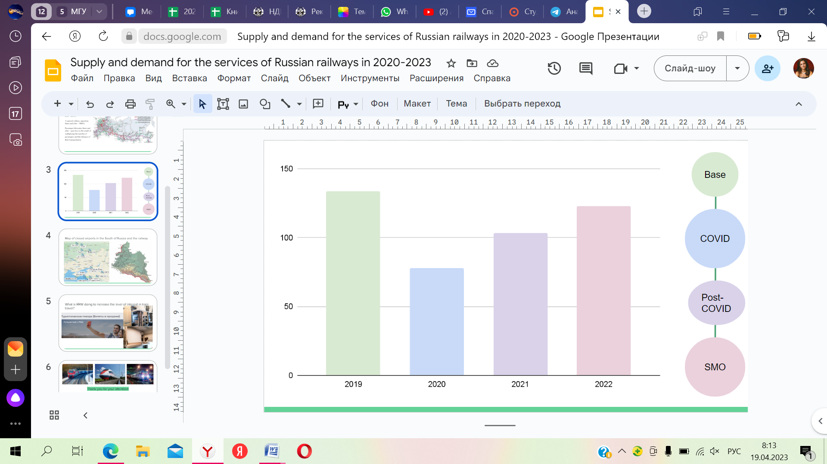

Figure 1. Schedule of changes in passenger traffic in 2019-2022

It should also be mentioned that RRW still cannot fully recover from the consequences of the COVID period. However, the data obtained for the first months of 2023 [7] give grounds for cautious optimism and suggest that this year will be the most successful of the three previous ones. The passenger traffic indicator is likely to approach the data of 2019.

**New ideas**

RRW is successfully increasing the number of passenger traffic in conditions of limited air traffic, which is undoubtedly more attractive to tourists as this means of transportation is faster and more comfortable. Anti-Russian sanctions have restricted the possibility of foreign tourism for Russians, which gives the company a chance to raise the level of interest in railway travel within the country.

One of the possible ways to increase the profitability of the company is to return to the Soviet experience of "railway tourism" with its wide range of developed routes of different levels: one-day, weekend trips, through ancient cities, across the country on the Trans-Siberian railway and not only [8]. A wide field for opportunities is opened by the renewal of rolling stock that was announced in 2021. It was stated that in some directions a new type of wagons would be used – the ones that have a high level of comfort of reserved seats and compartment equipment with personal lockers, curtains to create an individual space for each passenger and modern showers [4].

As has already been mentioned, people prefer air tourism because they can get to the place of their choice more quickly. So, the second idea for the company is to make trains faster than they are now by using the Chinese technologies: upgrading current railway lines and building new lines specifically for the movement of high-speed and maglev trains.

The staff of RRW are doing everything they can for their customers and use the best services at their disposal. There is every reason to believe that all this will make rail travel more attractive for Russians and increase passenger traffic. Besides, there is currently an upward trend in the liquidity of railway transportation, which allows us to hope for the growth of RRW's profits in the nearest future.

**Conclusion**

In the article we analyzed the latest trends in passenger traffic and reviewed the economic policy of RRW in the difficult period for the Russian and world economy 2020-2023. These facts helped us to predict the further prosperity of the company. This is very important because RRW is one of the main elements of the transport infrastructure in Russia, which provides, among other things, the development of the country's tourism sector.

**References**

1. Официальная страница РЖД «В 2021 году на сети ОАО «РЖД» перевезено свыше 1 млрд пассажиров», 04.01.2022. Retrieved from: <https://company.rzd.ru/ru/9397/page/104069?id=269758>
2. Официальная страница РЖД «В 2022 году на сети ОАО «РЖД» перевезено свыше 1,1 млрд пассажиров» 09.01.2023. Retrieved from: <https://company.rzd.ru/ru/9397/page/104069?id=280109>
3. Официальная страница РЖД «Перевозки пассажиров на инфраструктуре ОАО «РЖД» в 2019 г. выросли на 3,4 %», 09.01.2020. Retrieved from: <https://company.rzd.ru/ru/9397/page/104069?id=247441>
4. Официальная страница РЖД «Поезда с просторными плацкартными вагонами начнут перевозить пассажиров на юг во второй половине 2021 года», 02.10.2020. Retrieved from: <https://www.rzd.ru/ru/9284/page/3102?id=255572>
5. Официальная страница РЖД «Реформа: второй этап», 24.04.2004. Retrieved from: <https://company.rzd.ru/ru/9401/page/78314?accessible=true&id=18368>
6. Официальная страница РЖД «РЖД в 2020 году закупили 346 новых вагонов для электричек на более чем 28 млрд. рублей», 28.01.2021. Retrieved from: [https://company.rzd.ru/ru/9401/page/78314?id=193474#:~:text=](https://company.rzd.ru/ru/9401/page/78314?id=193474#:~:text=РЖД в 2020 году закупили,сумму более 28 млрд рублей)РЖД%20в%202020%20году%20закупили,сумму%20более%2028%20млрд%20рублей
7. Официальная страница РЖД «РЖД в цифрах». Retrieved from: <https://company.rzd.ru/ru/9377>
8. Официальная страница РЖД «Туристические поезда». Retrieved from: <https://www.rzd.ru/ru/10419/page/103290?id=19262#main-header>
9. Официальная страница Финам «Пассажирооборот на сети РЖД в 2020 году снизился на 41,5%», 11.01.2021. Retrieved from: <https://www.finam.ru/publications/item/passazhirooborot-na-seti-rzhd-v-2020-godu-snizilsya-na-41-5-20210111-11103/>